LAB ASSIGNMENT-1
PART A – COLLEGE DATABASE
STUDENT ( USN, SName, Address, Phone, Gender )
SEMSEC ( SSID, Sem, Sec )
CLASS ( USN, SSID )
SUBJECT ( Subcode, Title, Sem, Credits )
IAMARKS ( USN, Subcode, SSID, Test1, Test2, Test3, FinalIA )

1. STUDENT
STUDENT ( USN, SName, Address, Phone, Gender )
- Description: Stores personal details of students.
- Primary Key: USN
- Attributes:
  - USN – Unique Student Number
  - SName – Student Name
  - Address – Residential Address
  - Phone – Contact Number
  - Gender – Gender of the student
- Purpose: Uniquely identifies each student in the college database.

2. SEMSEC
SEMSEC ( SSID, Sem, Sec )
- Description: Represents semester and section details.
- Primary Key: SSID
- Attributes:
  - SSID – Semester-Section ID
  - Sem – Semester number
  - Sec – Section (A, B, C, etc.)
- Purpose: Helps group students based on semester and section.
3. CLASS
CLASS ( USN, SSID )
- Description: Associates students with their semester and section.
- Primary Key: (USN, SSID) (Composite Key)
- Foreign Keys:
  - USN → references STUDENT(USN)
  - SSID → references SEMSEC(SSID)
- Purpose: Resolves the relationship between STUDENT and SEMSEC.
4. SUBJECT
SUBJECT ( Subcode, Title, Sem, Credits )
- Description: Stores subject/course information.
- Primary Key: Subcode
- Attributes:
  - Subcode – Unique subject code
  - Title – Subject name
  - Sem – Semester in which subject is offered
  - Credits – Number of credits
- Purpose: Defines academic subjects offered by the college.
5. IAMARKS
IAMARKS ( USN, Subcode, SSID, Test1, Test2, Test3, FinalIA )
- Description: Stores internal assessment marks of students.
- Primary Key: (USN, Subcode, SSID) (Composite Key)
- Foreign Keys:
  - USN → references STUDENT(USN)
  - Subcode → references SUBJECT(Subcode)
  - SSID → references SEMSEC(SSID)
- Attributes:
  - Test1, Test2, Test3 – Internal test marks
  - FinalIA – Final internal assessment score
- Purpose: Tracks student performance in each subject.

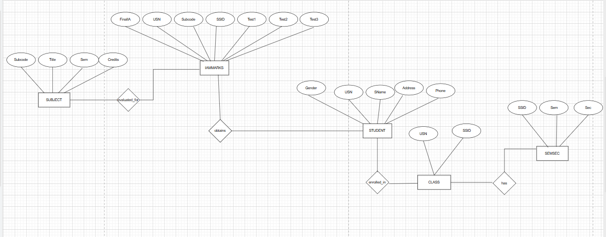

PART B – COMPANY DATABASE
EMPLOYEE ( SSN, Name, Address, Sex, Salary, Superssn, Dno )
DEPARTMENT ( Dno, Dname, Mgrssn, Mgrstartdate )
DLOCATION ( Dno, Dloc )
PROJECT ( PNo, PName, PLocation, DNo )
WORKS_ON ( SSN, PNo, Hours )

1. STUDENT
STUDENT ( USN, SName, Address, Phone, Gender )
- Description: Stores personal details of students.
- Primary Key: USN
- Attributes:
  - SName – Student name
  - Address – Residential address
  - Phone – Contact number
  - Gender – Gender of the student
- Purpose: Uniquely identifies each student.
2. SEMSEC
SEMSEC ( SSID, Sem, Sec )
- Description: Represents semester and section details.
- Primary Key: SSID
- Attributes:
  - Sem – Semester number
  - Sec – Section (A, B, etc.)
- Purpose: Groups students based on semester and section.
3. CLASS
CLASS ( USN, SSID )
- Description: Associates students with their semester and section.
- Primary Key: (USN, SSID) (Composite Key)
- Foreign Keys:
  - USN → references STUDENT(USN)
  - SSID → references SEMSEC(SSID)
- Purpose: Resolves the many-to-many relationship between STUDENT and SEMSEC.
4. SUBJECT
SUBJECT ( Subcode, Title, Sem, Credits )
- Description: Stores subject/course information.
- Primary Key: Subcode
- Attributes:
  - Title – Subject name
  - Sem – Semester in which subject is offered
  - Credits – Number of credits
- Purpose: Defines academic subjects offered by the college.
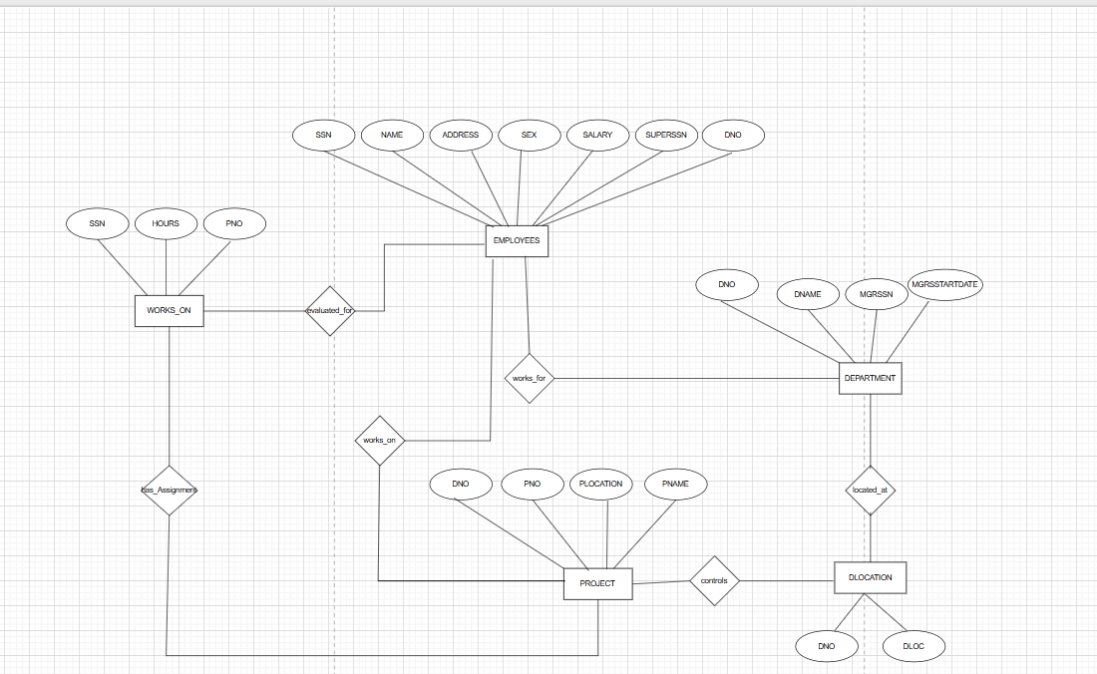
PART C – CUSTOMER SALE SCHEMA
Database Schema for a customer-sale scenario
Customer(Cust id : integer, cust_name: string)
Item(item_id: integer, item_name:string, price: integer)
Sale(bill_no:integer,bill_data:date,cust_id: integer, item_id:
integer, qty_sold: integer)

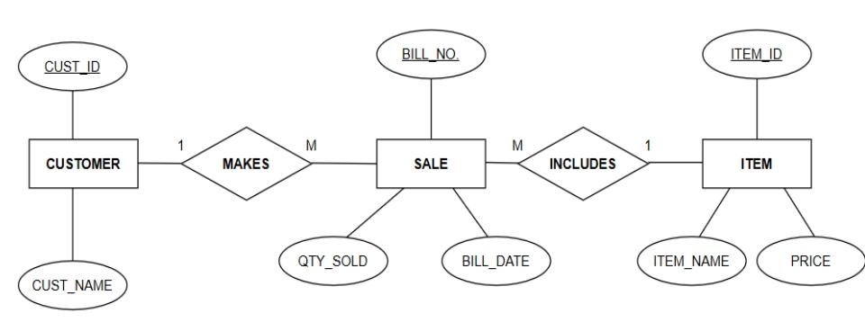

1. CUSTOMER
CUSTOMER ( Cust_id, Cust_name )
- Description: Stores details of customers.
- Primary Key: Cust_id
- Attributes:
  - Cust_name – Name of the customer
- Purpose: Identifies customers who make purchases.

2. ITEM
ITEM ( Item_id, Item_name, Price )
- Description: Stores information about items available for sale.
- Primary Key: Item_id
- Attributes:
  - Item_name – Name of the item
  - Price – Price of the item
- Purpose: Maintains item details and pricing information.
3. SALE
SALE ( Bill_no, Bill_date, Qty_sold )
- Description: Stores sales transaction details.
- Primary Key: Bill_no
- Attributes:
  - Bill_date – Date of the sale
  - Qty_sold – Quantity of items sold
- Purpose: Records individual sales transactions.

1. Create all relations with PRIMARY KEY and FOREIGN KEY constraints
STUDENT
CREATE TABLE STUDENT (
USN VARCHAR(10) PRIMARY KEY,
SName VARCHAR(50),
Address VARCHAR(100),
Phone VARCHAR(15),
Gender CHAR(1)
);
SEMSEC
CREATE TABLE SEMSEC (
SSID INT PRIMARY KEY,
Sem INT,
Sec CHAR(1)
);
CLASS
CREATE TABLE CLASS (
USN VARCHAR(10),
SSID INT,
PRIMARY KEY (USN, SSID),
FOREIGN KEY (USN) REFERENCES STUDENT(USN),
FOREIGN KEY (SSID) REFERENCES SEMSEC(SSID)
);

SUBJECT
CREATE TABLE SUBJECT (
Subcode VARCHAR(10) PRIMARY KEY,
Title VARCHAR(50),
Sem INT,
Credits INT
);
IAMARKS
CREATE TABLE IAMARKS (
USN VARCHAR(10),
Subcode VARCHAR(10),
SSID INT,
Test1 INT,
Test2 INT,
Test3 INT,
FinalIA INT,
PRIMARY KEY (USN, Subcode, SSID),
FOREIGN KEY (USN) REFERENCES STUDENT(USN),
FOREIGN KEY (Subcode) REFERENCES SUBJECT(Subcode),
FOREIGN KEY (SSID) REFERENCES SEMSEC(SSID)
);
CUSTOMER
CREATE TABLE CUSTOMER (
Cust_id INT PRIMARY KEY,
Cust_name VARCHAR(50)
);

ITEM
CREATE TABLE ITEM (
Item_id INT PRIMARY KEY,
Item_name VARCHAR(50),
Price INT
);
SALE
CREATE TABLE SALE (
Bill_no INT PRIMARY KEY,
Bill_date DATE,
Cust_id INT,
Item_id INT,
Qty_sold INT,
FOREIGN KEY (Cust_id) REFERENCES CUSTOMER(Cust_id),
FOREIGN KEY (Item_id) REFERENCES ITEM(Item_id)
);

2.Add a new column Email to STUDENT
ALTER TABLE STUDENT
ADD Email VARCHAR(50);

3.Apply NOT NULL constraint to Salary and Price
EMPLOYEE (Salary)
ALTER TABLE EMPLOYEE
MODIFY Salary INT NOT NULL;

ITEM (Price)
ALTER TABLE ITEM
MODIFY Price INT NOT NULL;
4.Rename attribute SName to StudentName in STUDENT
ALTER TABLE STUDENT
RENAME COLUMN SName TO StudentName;

5.Drop the DLOCATION relation
DROP TABLE DLOCATION;

DML QUESTIONS (Data Manipulation Language)
1.Insert at least 10 tuples
CUSTOMER
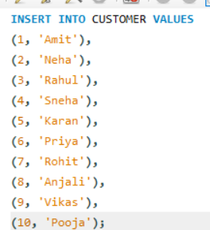

OUTPUT:
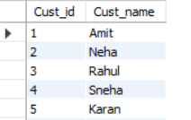

ITEM
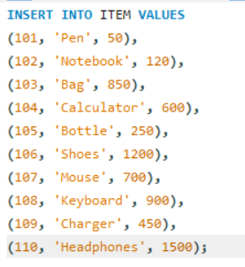
OUTPUT:
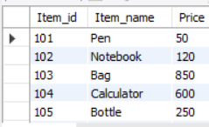

SALE
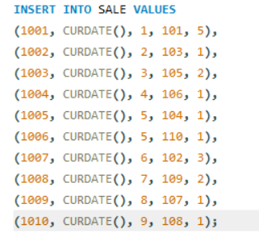
OUTPUT:
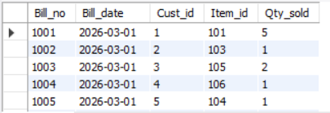

2.List all bills of the current date with customer and item names
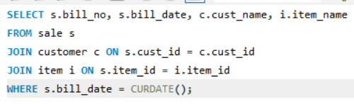

OUTPUT:
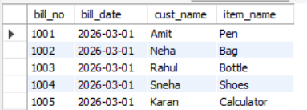

3.Display total bill amount (qty × price)
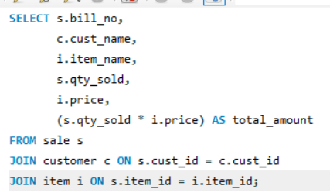
OUTPUT:
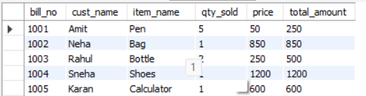

4.List customers who purchased products priced above 200
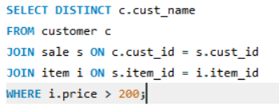
OUTPUT:
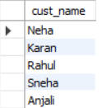

5. Count number of products purchased by each customer
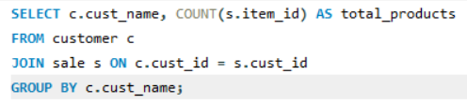
OUTPUT:
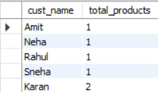

6. List products purchased by customer with Cust_id = 5
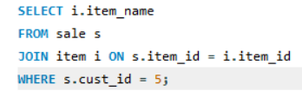
OUTPUT:
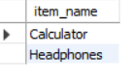
7.Create a VIEW showing bill details with amount
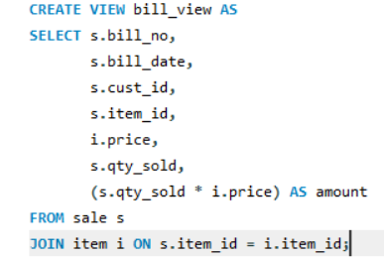
OUTPUT:
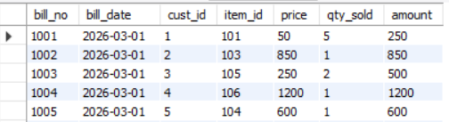

8.Create a VIEW showing daily sales for the last one week
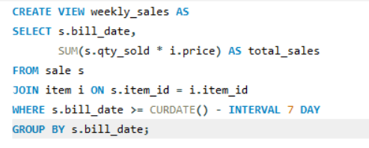
OUTPUT:
